Jack Berberian

CIS 245

2/26/22

Continue Setup – CentOS Stream 9

Some things to know beforehand:

* By adding -y to a command at the end, you can skip prompts that ask you to confirm whether you’d like to do something like installing a program, removing a program, or upgrading something.
* Sudo is needed for commands that need administrative privileges such as installing a program, and changing system settings to name a few.
* DNF and Yum are two default package managers (software storage places) for Cent OS.

1. How to install Tmux

* Tmux allows a user to use multiple terminal windows in one session
* Command to enter: **sudo dnf install tmux -y**

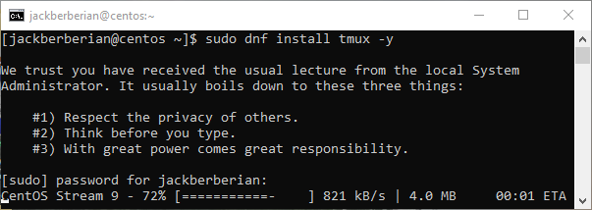

To see if you installed it correctly, enter tmux into the commandline:

* + Command: tmux
  + Text

    Description automatically generated

1. How to install emacs
   1. (Emacs is an alternative text editor)
   2. Since emacs isn’t included the with a standard installation of Cent OS, you have to download special packages meant for enterprise users and then install it.
   3. First command:
   4. **sudo dnf install epel-release -y**
   5. 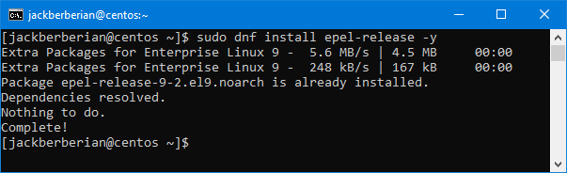
   6. Second Command:
   7. **sudo dnf install emacs -y**
   8. 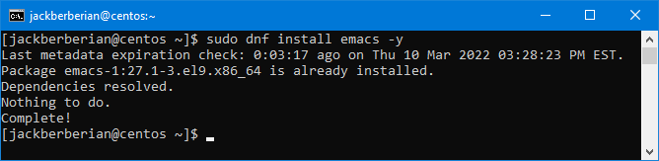
   9. To see if emacs installed correctly, enter:
   10. Emacs
   11. Text

       Description automatically generated
2. How to install Fail2Ban
   1. Enter:
      1. sudo dnf install fail2ban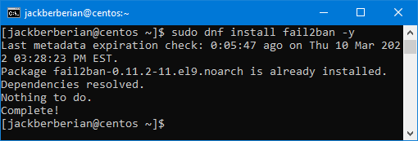
      2. sudo systemctl enable fail2ban
      3. sudo systemctl start fail2ban
      4. sudo systemctl status fail2ban
      5. Text

         Description automatically generated
      6. Copy the original configuration file for Fail2Ban to /etc/fail2ban/jail.local
      7. Enter this command:
      8. sudo cp /etc/fail2ban/jail.conf /etc/fail2ban/jail.local
      9. 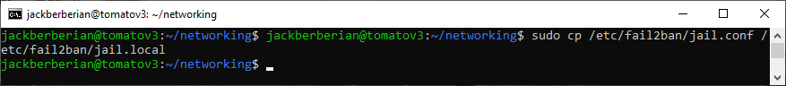
      10. Now edit the /etc/fail2ban/jail.local file with your text editor.
      * Enter:
      * sudo nano /etc/fail2ban/jail.local
      * Text

        Description automatically generated
   * Locate the [DEFAULT} section
     + (Green text above)
     + Here you can change the number of seconds that a host is banned, the number of failures an IP address is allowed, and how long to ban an IP if they exceed their allotted tries.
     + Text

       Description automatically generated
   * You can also add your IP address of your computer incase you get locked out (still in the /etc/fail2ban/jail.local
   * A screenshot of a computer

     Description automatically generated

* If you make any changes, enter these commands to restart fail2ban and check the status.
  + sudo service fail2ban restart
  + sudo systemctl status fail2ban
  + Text

    Description automatically generated

1. How to install cowsay

First enter:

* **Sudo** **wget** [**https://download-ib01.fedoraproject.org/pub/epel/8/Everything/x86_64/Packages/c/cowsay-3.04-16.el8.noarch.rpm**](https://download-ib01.fedoraproject.org/pub/epel/8/Everything/x86_64/Packages/c/cowsay-3.04-16.el8.noarch.rpm)
* Then enter:
* **sudo yum localinstall cowsay-3.04-4.el7.noarch.rpm -y**
* **Text

  Description automatically generated**
* **Text

  Description automatically generated**

What this does is pulls the official package for cowsay from Fedora’s website and then by entering yum localinstall (the filename), it tells the package manager to install the local file from where it’s downloaded in the directory.

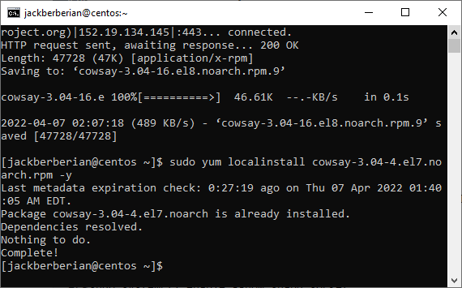

* To see if cowsay installed correctly, enter
  + Cowsay hello-world
  + Text

    Description automatically generated

1. How to install lolcat

Here first enter:

1. Sudo yum install snapd
2. sudo systemctl enable --now snapd.socket
3. sudo snap install lolcat

What this does is first install the package manager snapd since lolcat is not available natively, then it’s enabled as a system process and then finally by entering, snap install lolcat, we are able to install lolcat.

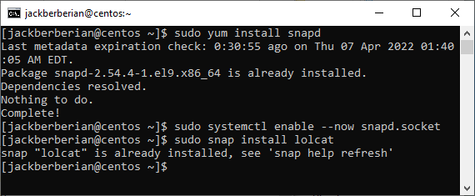

* Alternatively to install lolcat, you could enter:
* Ruby is also another package manager and a gem is the package installation method.
  + yum install ruby
  + Download the most recent version from GitHub:
    - wget <https://github.com/busyloop/lolcat/archive/master.zip>
  + Unzip the file:
    - Unzip master.zip
  + Go to the directory it’s in.
    - Cd lolcat-master/bin
  + Install it with Gem
    - Gem install lolcat
  + To enter it all at once, enter this:
    - yum install ruby && wget https://github.com/busyloop/lolcat/archive/master.zip && unzip master.zip && cd lolcat-master/bin && gem install lolcat
  + Text

    Description automatically generated
* To see if lolcat installed correctly, enter either
* Hostname | lolcat
* Lolcat -h
* If you pipe words to lolcat like the screenshot, it’ll colorize them.
  + Text

    Description automatically generated

1. How to update VI to vim

Enter:

**Sudo dnf install vim**

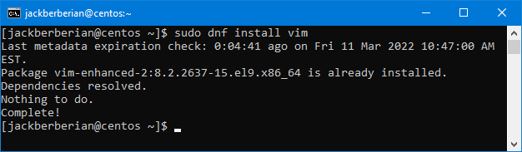

* To see if Vim was installed correctly, enter:
  + VIM
  + Text

    Description automatically generated

1. How to update your servers if needed

* Enter
  + Sudo dnf update && sudo dnf upgrade
    - Text

      Description automatically generated

1. Repo List

Enter:

1. Yum repolist
2. Dnf repolist

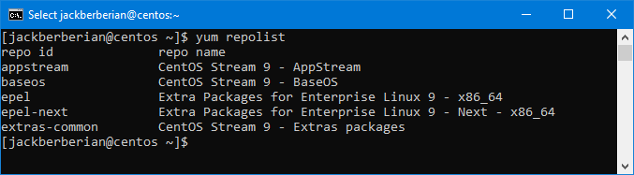

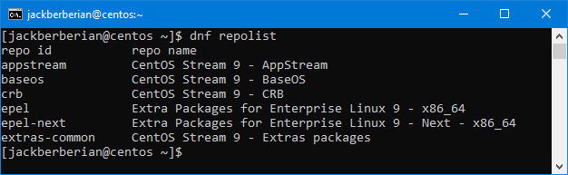

Short Document Showing Where Repos Live, How I can find them, How to Add/Modify a Repo or PPA

* List of Repos:
  + To find a list of all the repos installed with the package manager yum, enter:
  + Text

    Description automatically generated
* You can add a repo by either adding to the /etc/yum.conf file or adding a .repo file in the directory /etc/yum.repos.d/
* A screenshot of a computer

  Description automatically generated with medium confidence
* A screenshot of a computer

  Description automatically generated
* To remove packages, enter:
  + yum remove package-name
  + Text

    Description automatically generated
* To list a package, enter:
  + Yum list | grepyum lis (program name)
  + A screenshot of a computer

    Description automatically generated
  + Be aware some systems could have a lot of packages installed so you’ll want to pipe the output to grep to search.

What I’ve Installed on my Servers, and when they were last updated.

On CentOS, I installed tmux, emacs, fail2ban, cowsay, and lolcat as well as updated VI to VIM and the updated the whole system. I reinstalled and updated everything on 2022/05/22.

Citations:

<https://access.redhat.com/documentation/en-us/red_hat_enterprise_linux/6/html/deployment_guide/sec-managing_yum_repositories>

<https://www.inmotionhosting.com/support/server/linux/delete-repos-centos/>

<https://www.tecmint.com/lolcat-command-to-output-rainbow-of-colors-in-linux-terminal/>

<https://www.a2hosting.com/kb/security/hardening-a-server-with-fail2ban>